Madro-Tertiary Geoflora of the Pacific Northwest

Beginning about 65 million years ago, the climate of Western North American began to cool and became more arid, partly in response to the initial uplift of the Sierra Nevada and Coast Range, and partly due to falling global temperatures and increasing global aridity. The rainshadow that resulted from these mountain barriers allowed the Madro-Tertiary Geoflora (from the Sierra Madre of Mexico) to expand is range and replace some of the Arcto-Tertiary plants in California, the Columbia Plateau, and Western Oregon. Subsequent uplift of the Cascades increased the rainshadow effect in the interior PNW especially in the last ~20 million years. Rainshadow effects of the Olympic Mountains and Vancouver Island have created enough aridity for some of the drought-adapted Madro Tertiary Geoflora to extend well into Western Canada.

Most of the plants of Madro-Tertiary Geoflora in the PNW are drought adapted with some combination of small, deciduous, or waxy leaves. Some are found in fairly high precipitation zones (such as the coast) if the soils are coarse-grained with minimal moisture holding capacity.

Here are some prominent plants from this Geoflora to know:

Pacific Madrone Arbutus menzesii
http://www.fotopedia.com/items/flickr-2616024346

Manzanita (genus Arctostaphylos) various species
http://www.fotopedia.com/wiki/Manzanita

Western Juniper (Juniperus occidentalis)
http://www.wou.edu/~mcgladm/Geography%20105%20%20Physical%20Geography/for%20exam%203/Madro%20Tertiary%20Geoflora/western%20juniper.jpg

Poison Oak (Toxicodendron diversilobum)
http://walking.about.com/od/medfirstaid/ig/Poison-Oak-Photos/Poison-Oak-Bush.htm

Oregon White Oak (Quercus garryana)
http://www.oregon.gov/ODF/URBAN_FORESTS/docs/FeaturedTreeOregonWhiteOak.pdf?ga=t

students – if you’re interested in global temperature changes, I sourced the following from: http://math.ucr.edu/home/baez/temperature/temperature.html#65Myr

Temperatures over the last 65 million years
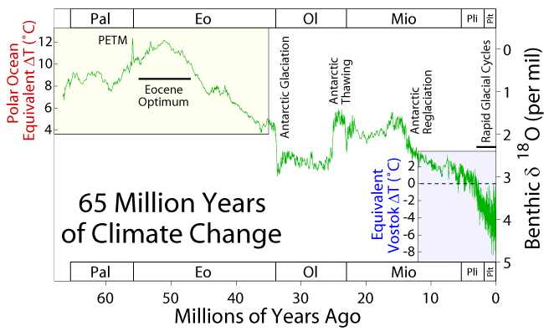
This shows the Earth's temperature since the extinction of the dinosaurs about 65 million years ago - the end of the Mesozoic and beginning of the Cenozoic. At first the Earth warmed up, reaching its warmest 50 million years ago: the "Eocene Optimum". The spike before that labelled "PETM" is a fascinating event called the Paleocene-Eocene Thermal Maximum. At the end of the Eocene the Earth cooled rapidly and the Antarctic acquired year-round ice. After a warming spell near the end of the Oligocene, further cooling and an increasingly jittery climate led ultimately to the current age of rapid glacial cycles - "ice ages".
This chart is taken from here:
- Robert Rohde, 65 million years of climate change, for Global Warming Art.

